Database Normalization Documentation

Elbio Iseas

DBM/380

Jan 23, 2014

Bruce Fullwood

**Documentation for Database Normalization**

1NF

Table name: ART_WORK

Primary Key is ART_WORK_ID

The whole database environment turns around this table.

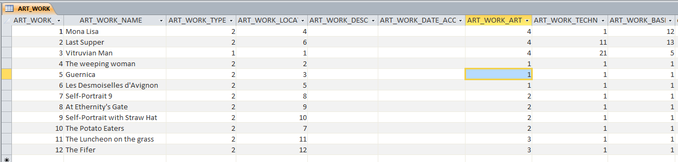

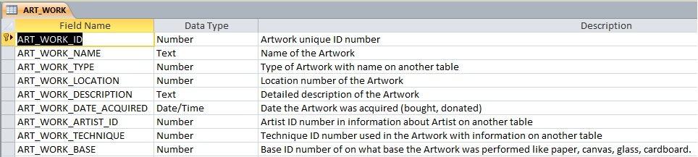

Foreign keys are: ART_WORK_TYPE

ART_WORK_LOCATION

ART_WORK_ARTIST_ID

ART_WORK_TECHNIQUE

ART_WORK_BASE

The other tables are:

Table name: ART_WORK_TYPE

Primary Key is ART_WORK_TYPE_ID

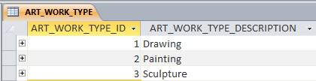

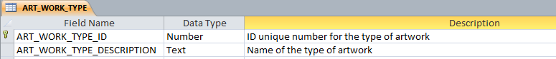

Table name: LOCATION

Primary Key is LOCATION_ID

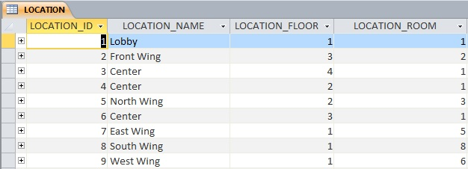

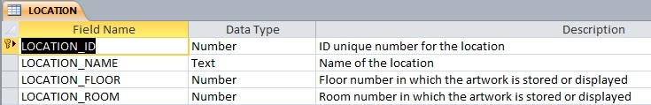

Table name: ARTIST

Primary Key is ARTIST_ID

Foreign Key is ARTIST_MOVEMENT

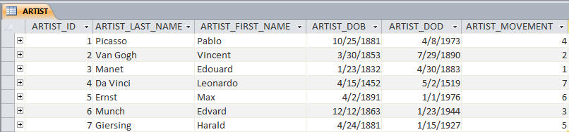

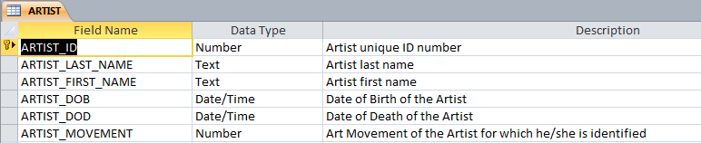

Table name: MOVEMENT

Primary Key is MOVEMENT_ID

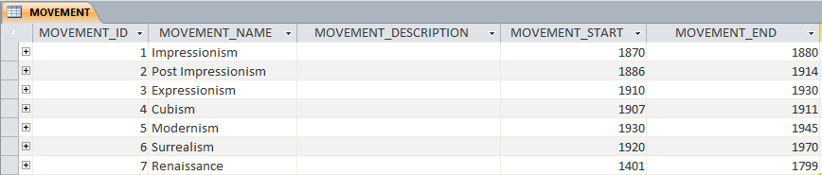

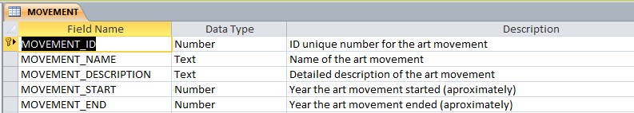

Table name: ART_WORK_TECHNIQUE

Primary Key is ART_WORK_TECHINQUE_ID

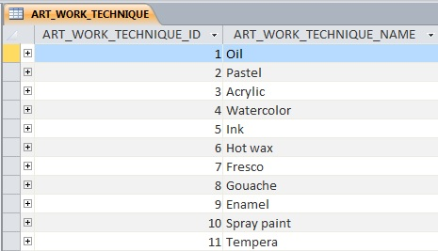



Table name: TYPE_BASE

Primary Key is TYPE_BASE_ID

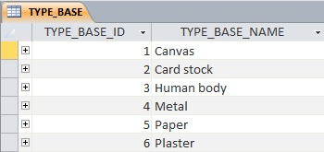

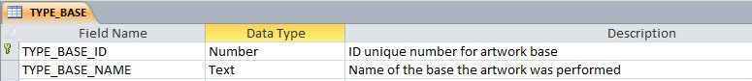

There are no duplicate columns in tables, just foreign keys referencing other primary keys in different tables. Information on other tables is linked by relationships.

2NF

It was necessary to create external tables to the WORK_ART table to avoid redundancy with the information needed for the database purpose, and to save storage space. These external tables have their own primary keys.

3NF

The Museum database was normalized with no redundancy. Information in tables is no repeated once and no columns are repeated.

References

<http://support.microsoft.com/kb/283878>